WEEK 12

QUESTION 1

A binary number is a combination of 1s and 0s. Its n th least significant digit is the n th digit starting from the right

starting with 1. Given a decimal number, convert it to binary and determine the value of the the 4 th least significant

digit.

**Example**

number = 23

· Convert the decimal number 23 to binary number: 23 10 = 2 4 + 2 2 + 2 1 + 2 0 = (10111)2.

· The value of the 4 th index from the right in the binary representation is 0.

**Function Description**

Complete the function fourthBit in the editor below.

fourthBit has the following parameter(s):

int number: a decimal integer

Returns:

int: an integer 0 or 1 matching the 4th least significant digit in the binary representation of number.

**Constraints**

0 ≤ number < 2 31

**Input Format for Custom Testing**

Input from stdin will be processed as follows and passed to the function.

103The only line contains an integer, number.

**Sample Case 0**

**Sample Input 0**

STDIN Function

----- --------

32 → number = 32

**Sample Output 0**

0

**Explanation 0**

· Convert the decimal number 32 to binary number: 3210 = (100000)2.

· The value of the 4th index from the right in the binary representation is 0.

**Sample Case 1**

**Sample Input 1**

STDIN Function

----- --------

77 → number = 77

**Sample Output 1**

1

**Explanation 1**

· Convert the decimal number 77 to binary number: 7710 = (1001101)2.

· The value of the 4th index from the right in the binary representation is 1.

PROGRAM: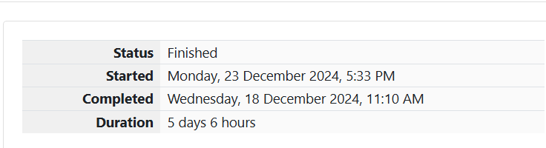

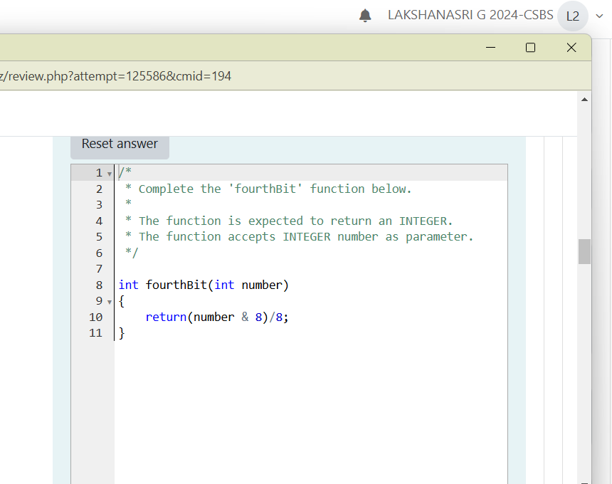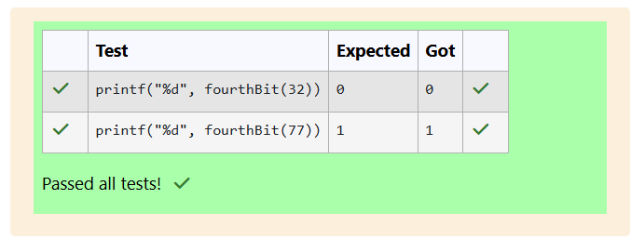

QUESTION 2

Determine the factors of a number (i.e., all positive integer values that evenly divide into a number) and then return the

p th element of the list, sorted ascending. If there is no p th element, return 0.

**Example**

n = 20

p = 3

The factors of 20 in ascending order are {1, 2, 4, 5, 10, 20}. Using 1-based indexing, if p = 3, then 4 is returned. If p >

6, 0 would be returned.

**Function Description**

Complete the function pthFactor in the editor below.

pthFactor has the following parameter(s):

int n: the integer whose factors are to be found

int p: the index of the factor to be returned

*/

int fourthBit(int number)

{

int binary[32];

int i=0;

while(number>0)

{

binary[i]=number%2;

number/=2;

i++;

}

if(i>=4)

{

return binary[3];

}

else

return 0;

}

6

7

8

9

10

11

12

13

14

15

16

17

18

19

20

21

22

23

24

25

105Returns:

int: the long integer value of the p th integer factor of n or, if there is no factor at that index, then 0 is returned

**Constraints**

1 ≤ n ≤ 10 15

1 ≤ p ≤ 10 9

Input Format for Custom Testing

Input from stdin will be processed as follows and passed to the function.

The first line contains an integer n, the number to factor.

The second line contains an integer p, the 1-based index of the factor to return.

**Sample Case 0**

**Sample Input 0**

STDIN Function

----- --------

10 → n = 10

3 → p = 3

**Sample Output 0**

5

**Explanation 0**

Factoring n = 10 results in {1, 2, 5, 10}. Return the p = 3 rd factor, 5, as the answer.

**Sample Case 1**

**Sample Input 1**

STDIN Function

----- --------

10 → n = 10

5 → p = 5

106**Sample Output 1**

0

**Explanation 1**

Factoring n = 10 results in {1, 2, 5, 10}. There are only 4 factors and p = 5, therefore 0 is returned as the answer.

**Sample Case 2**

**Sample Input 2**

STDIN Function

----- --------

1 → n = 1

1 → p = 1

**Sample Output 2**

1

**Explanation 2**

Factoring n = 1 results in {1}. The p = 1st factor of 1 is returned as the answer.

PROGRAM: